Web Design Report 2023
Cian Billings – S00236781

GitHub URL- https://cianbillings.github.io/Web-Design-CA/

GitHub Repository - https://github.com/CianBillings/Web-Design-CA
Initial Design
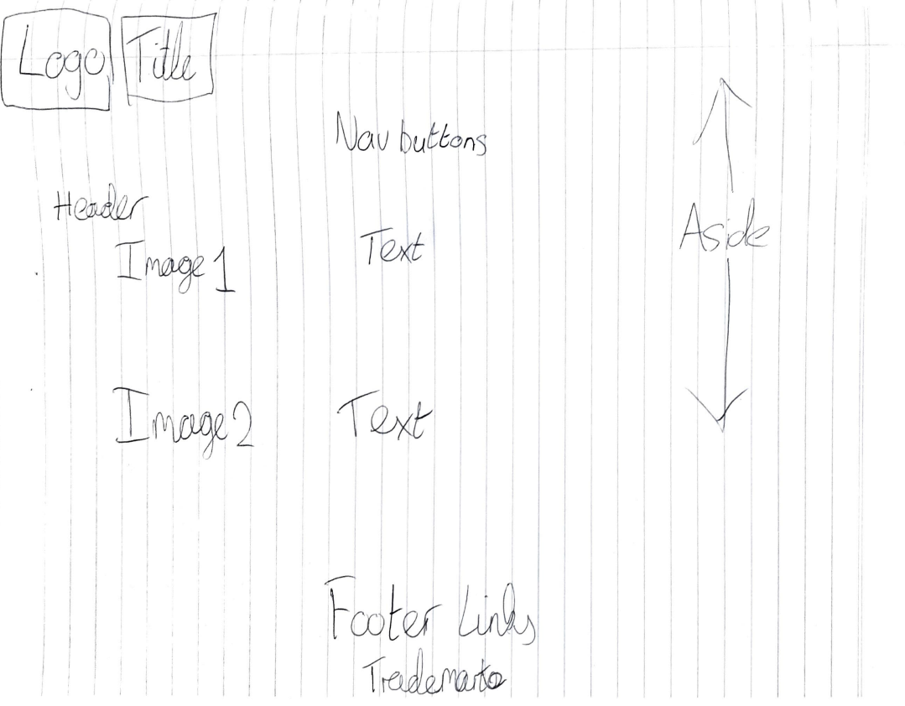
This was my initial plan for my website. I followed my initial thoughts through my development and my final product was similar to the image in my head at the beginning.
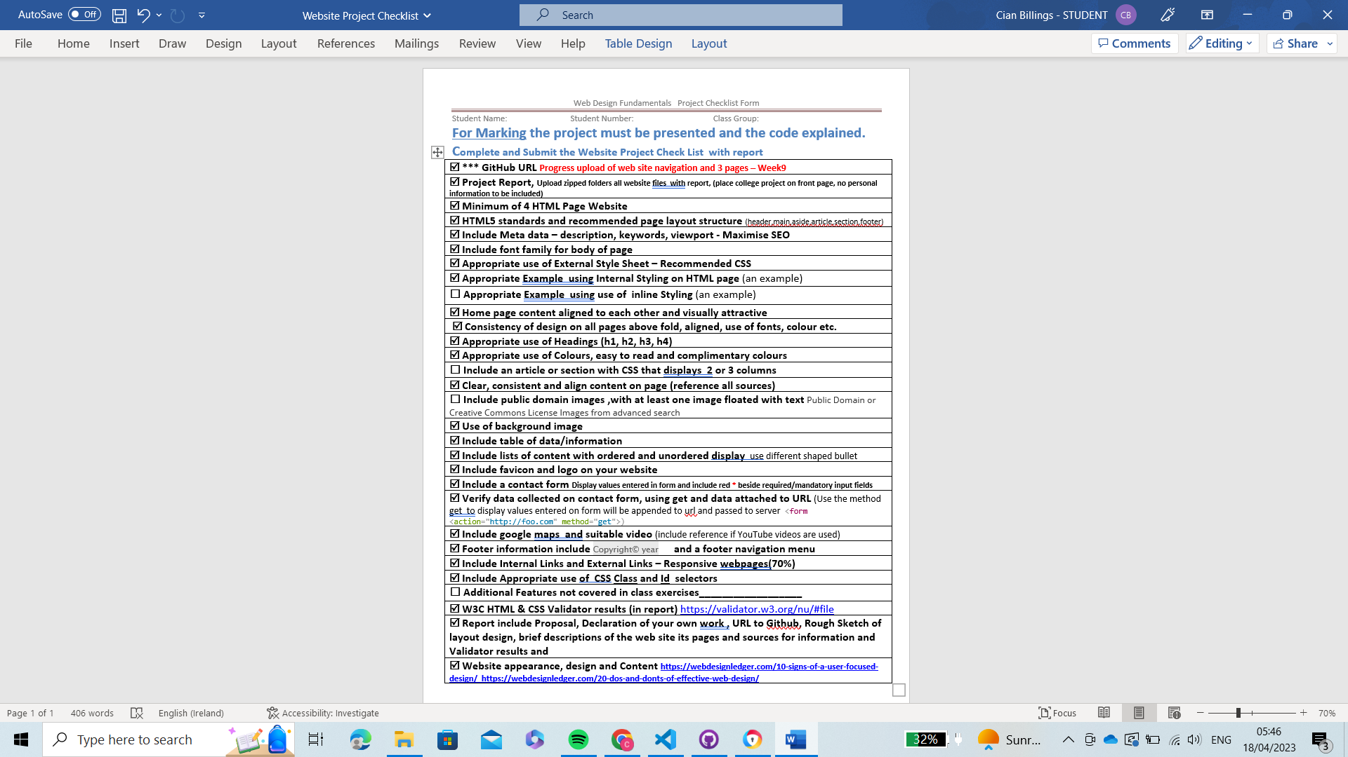
Brief summary of pages
Index
On this page my website gives a brief summary of different varieties of holidays around the world. This page gives plenty of insight into several countries and why you should visit them using researched information
Destinations
The next three pages are dedicated to my personal favourite holiday destinations I have experienced in life. I feel personal stories and opinions of places allows for a better overall view of what to expect.
These pages give in depth insight into these different holiday locations and what to do and expect while there.
Prices
This page shows a table of prices while comparing prices and also giving valuable information for people budgeting on a holiday. This page also shows a quick video to help with budgeting for holidays.

Contact Us
This page consists of different ways to contact us while also showing the location of our main office and a quick forum to fill out for any further help with travel guidance.

Declaration of own work

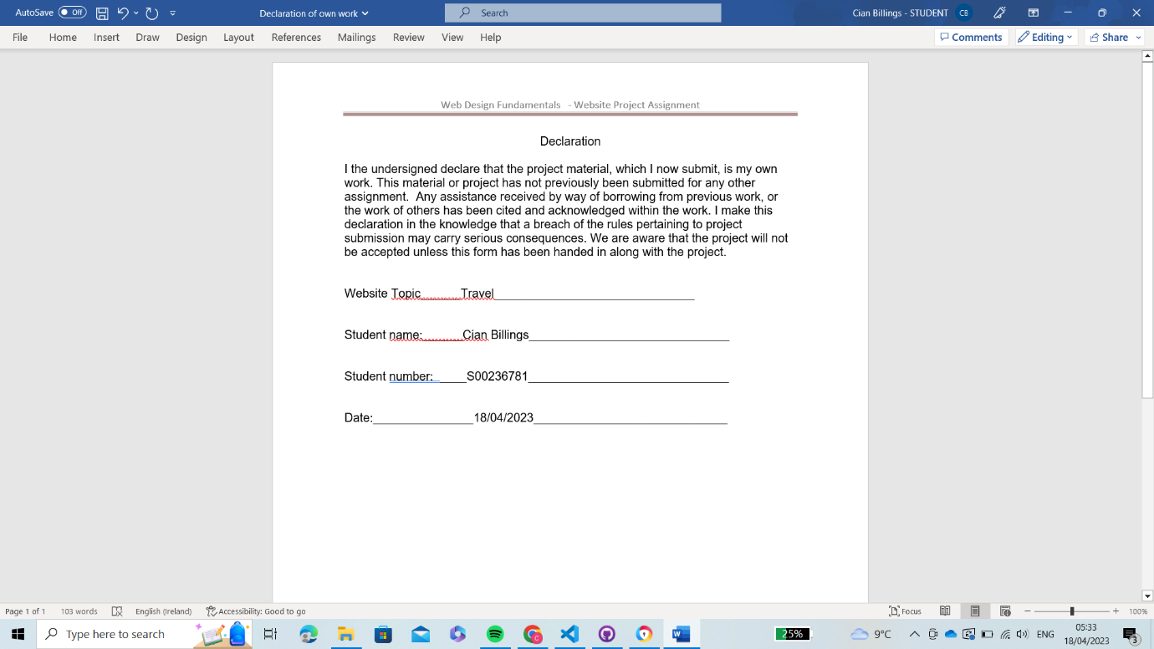

Validation screen shots
